JAVA網路應用Homework #1

工資103 H34996158 侯瑋明

Q1 Exercise7.10

import java.util.Scanner;

import java.util.Arrays;

public class DuplicateElimination

{

public static void main( String[] args )

{

Scanner scanner = new Scanner( System.in );

int[] array = new int[6];

array[5]=101;

int num =0; //variable

while(true)

{

System.out.print(" Please input 5 numbers(10~100): ");

for(num =0; num <5; num++) //input 5 numbers

{

array[num] = scanner.nextInt();

if(array[num]<10 || array[num]>100)

{

System.out.printf( " Please input correct number! ");

System.out.println();

num = 0;

break;

}

}

if(num ==5)

break;

}

Arrays.sort(array); //sort

for(num =1; num <6; num++) //change duplicates' value

{

if(array[num-1]==array[num])

array[num]=9;

}

for(int value : array) //print out array

if(value>=10&&value<=100)

System.out.printf( "%d ", value );

}

}

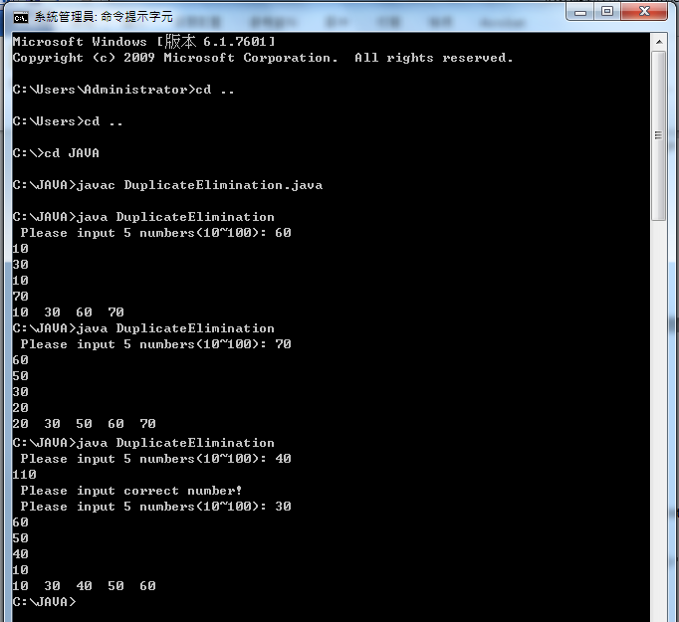

Q2 Exercise7.15

import java.util.Scanner;

import java.util.Arrays;

public class TotalSales

{

public static void main( String[] args )

{

Scanner scanner = new Scanner( System.in );

int answer;

int[] data = new int[3];

int[][] sales = new int[6][5];

while(true) //Key in 資料

{

System.out.print(" Input information(input any number can be continued) (-1 to leave): ");

answer = scanner.nextInt();

if(answer == -1)

break;

System.out.print(" Please input the salesperson number(1~4): ");

data[0] = scanner.nextInt();

if(data[0]<1 || data[0]>4)

{

System.out.print(" Please input correct number! ");

System.out.println();

continue;

}

System.out.print(" Please input the product number(1~5): ");

data[1] = scanner.nextInt();

if(data[1]<1 || data[1]>5)

{

System.out.print(" Please input correct number! ");

System.out.println();

continue;

}

System.out.print(" Please input total dollar value of that product sold that day: ");

data[2] = scanner.nextInt();

if(data[2]<0)

{

System.out.print(" Please input correct value! ");

System.out.println();

continue;

}

sales[data[1]-1][data[0]-1]++; //資料儲存

sales[data[1]-1][4] += data[2];

sales[5][data[0]-1] += data[2];

sales[5][4] += data[2];

//印出結果表格

System.out.println(" Salesperson1 Salesperson2 Salesperson3 Salesperson4 TotalValue");

for(int i=0; i<5; i++)

{

System.out.printf("Product%d",i+1);

for(int j=0; j<5; j++)

{

System.out.printf(" %d", sales[i][j]);

}

System.out.println();

}

System.out.printf("TotalVal");

for(int j=0; j<5; j++)

System.out.printf(" %d", sales[5][j]);

System.out.println();

}

}

}

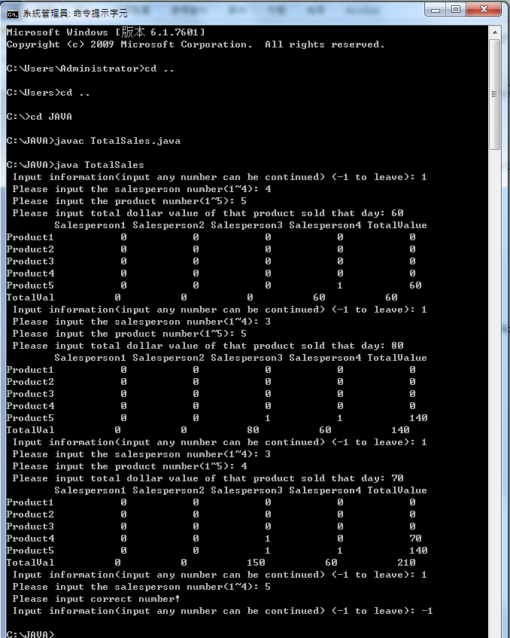

Q3 Describe your experience on using Eliza test並說明略述一下，該程式的設計原理

Ans: 整體應該是以一個龐大的資料庫做為後盾，當使用者輸入特定關鍵字，則回答相關句子，而這也有點像switch功能的超級放大版，當然，要能完成此程式必須要有非常多的資料以針對使用者的問題，來對應對相關其問題的句子，構成彷彿人與人對話般流暢、不死板。